SET WINDOWS VARIABLE ENVIRONMENT
- Open System Properties box
Method 1: Search “env” and open “Edit the system environment”
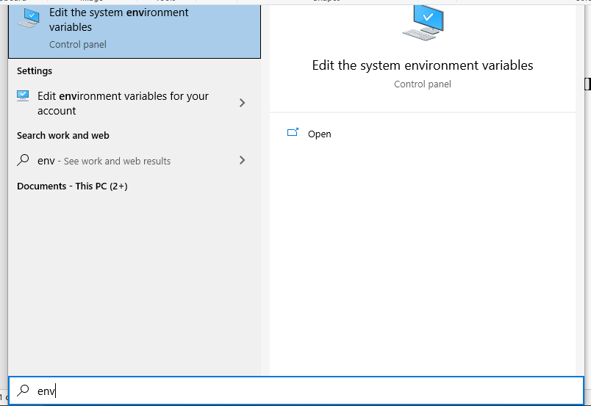
Method 2: Open: Control panel” -> -> System -> Advanced system settings -> Advanced
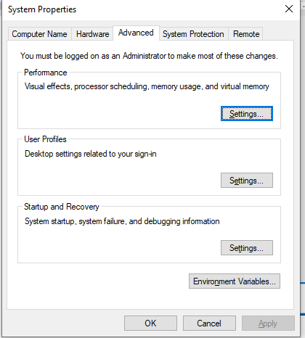
- Set path for Environment Variables
+) Open Environment Variables box
- Click: Environment Variables -> Path
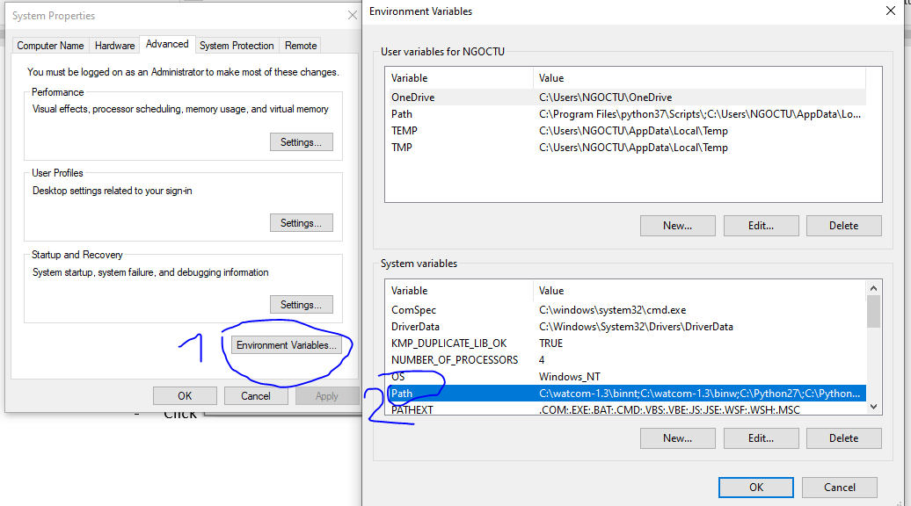
- Click “new” and add path for executable files which you would like to open in cmd terminal
(Example g++, gcc in mingw64: add C:\msys64\mingw64\bin and C:\msys64\usr\bin)
